Enhancement for ITX map naming in the Naming Tool

When entering values for the source and the destination message types for ITX maps, there are now two fields to fill:
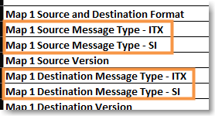
The ”SI” fields accept any data you enter.
The ”ITX” fields must be filled with a value that results in a valid lookup using the table in the cells T1:U669 in the ”DropDown - DO NOT EDIT” worksheet.
Remember, if you do not find an exact match, use a value that the message type mostly resembles and which will result in a valid lookup in the table.

Example:
We need a new map for a new partner, Manticore Ltd.
The source message type is the generic outbound IFTMIN D10B message.
The destination message is a partner-specific csv format which the partner refers to as MultStageImpMiss, version 5.
In the Naming Tool, the user selects ”ITX” in the ”SI or ITX Map and/or Code Lists” field, enters a ”1” in the ”Number of Maps” field, an finally clicks the ”Generate Tables For Maps” button to create an ITX map name table.
For the source message type, the user enters the IFTMIN message type in both the ”Map 1 Destination Message Type - SI” and the ”Map 1 Destination Message Type - ITX” fields as we already have a conversion for this value in the message type conversion table.
For the destination message type, the user enters the partner’s message type name in the ”Map 1 Destination Message Type - SI” field, since that field accepts whatever is entered in it. But there is no conversion for ”MultStageImpMiss” in the conversion table. Instead, the user considers the message type and purpose and decides that the ”MultStageImpMiss” message mostly resembles a SHIPMENT message. The message type conversion table does include a record for ”SHIPMENT” making it a valid value to enter in the ”Map 1 Destination Message Type – ITX” field.
The completed table looks like this:
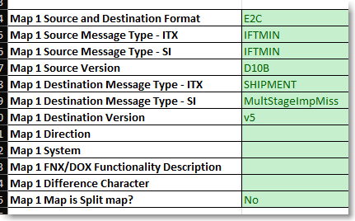
The map name values generated look like this:
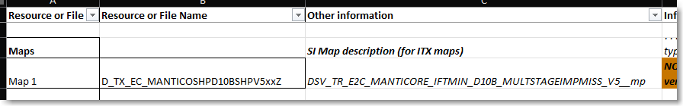
We see that the ITX map name includes the correct conversions for IFTMIN -> SHP and for SHIPMENT -> SHP, whereas the SI map name simply uses the values as entered in the ” Map 1 Source Message Type – SI” and the Map 1 Destination Message Type – SI” fields.

When Creating SI Map Names
If the maps to be created are actually SI maps and the ”SI or ITX Map and/or Code Lists” field is set to ”SI”, the ITX-specific fields are omitted in the map naming tables:
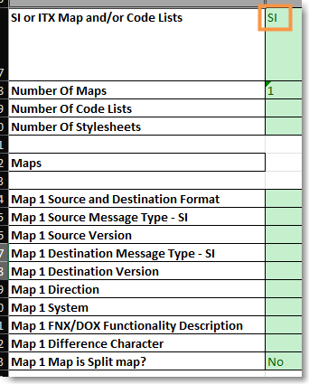
And the SI map name appears as normal in the expected place in the ”Resource and file naming” worksheet:
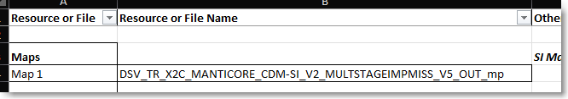

/Tech Team™, 2025-02-24

